# **Problems #21 to #25**

=======================================

# **Problem 21**

==============================

Description: Write A program to get: Circle Area Along The Circumference

=======================================================

#include <iostream>

#include <cmath>

using namespace std;

float ReadCircumference(){

float L;

cout<<"\nPlease Enter Circumference: ";

cin>> L;

return L;

}

float CircleAreaByCircumference(float L){

const float PI = 3.141592653589793238;

float Area = pow(L,2) / (4 * PI);

return Area;

}

void PrintResult(float Area){

cout<<"\nThe Area Is: "<<Area<<endl;

}

int main(){

PrintResult(CircleAreaByCircumference(ReadCircumference()));

return 0;

}

========================================================================

The output:

===========

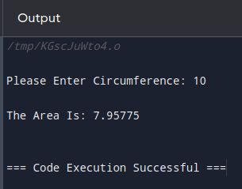

========================================================================

# **Problem 22**

=====================

Description: Circle Area Inscribed in an isosceles Triangle

================================================

#include <iostream>

#include <cmath>

using namespace std;

float ReadTriangleData(float& A, float& B){

cout<<"\nPlease Enter Triangle Side A: ";

cin>> A;

cout<<"\nPlease Enter Triangle Base B: ";

cin>>B;

}

float CircleAreaByTriangle(float A, float B){

const float PI = 3.141592653589793238;

float Area = PI * (pow(B,2) / 4) * ((2* A - B) / (2 * A + B));

return Area;

}

void PrintResult(float Area){

cout<<"\nThe Area Is: "<<Area<<endl;

}

int main(){

float A, B;

ReadTriangleData(A,B);

PrintResult(CircleAreaByTriangle(A,B));

return 0;

}

========================================================================

The output:

==========

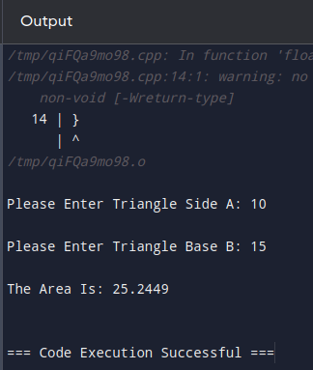

========================================================================

# **Problem 23**

=======================

Description: Circle Area Described Around an Arbitrary Triangle

===================================================

#include <iostream>

#include <math.h>

using namespace std;

void ReadTriangleData(float & A, float& B, float& C){

cout<<"\nEnter A: ";

cin>>A;

cout<<"\nEnter B: ";

cin>> B;

cout<<"\nEnter C: ";

cin>>C;

}

float CircleAreaByTriangle(float A, float B, float C){

const float Pi = 3.141592653589793238;

float P;

P = (A + B + C) /2;

float T;

T = (A * B * C) / (4 * sqrt(P * (P - A) *(P - B) *(P - C)));

float Area= Pi * pow(T,2);

return Area;

}

void PrinResult (float Area){

cout<<"\nThe Area Is: "<<Area<<endl;

}

int main(){

float A, B, C;

ReadTriangleData(A,B, C);

PrinResult(CircleAreaByTriangle(A,B, C));

return 0;

}

========================================================================

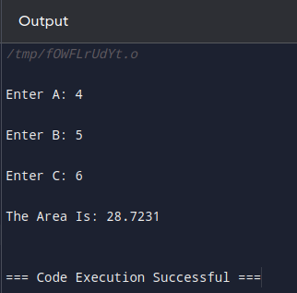

========================================================================

# **Problem 24**

====================

Number Validation

==================

#include <iostream>

#include <math.h>

using namespace std;

int ReadAge(){

int Age;

cout<<"\nEnter You're Age: ";

cin>> Age;

return Age;

}

bool ValidateNumberInRange(int Number, int From, int To){

return (Number >= From && Number<= To);

}

void PrintResult(int Age){

if(ValidateNumberInRange(Age,18,45))

cout<<Age<<"\n Is A Valid Age \n";

else

cout<<Age<<"\n Is A Invalid Age \n";

}

int main(){

PrintResult(ReadAge());

return 0;

}

========================================================================The output:

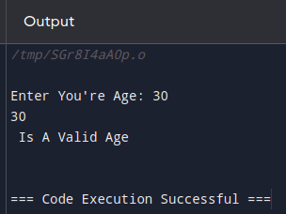

========================================================================

# **Problem 25**

=====================

Write A program : Read Until Age Between 18 and 45

==========================================

#include <iostream>

#include <math.h>

using namespace std;

int ReadAge(){

int Age;

cout<<"\nEnter You're Age: ";

cin>> Age;

return Age;

}

bool ValidateNumberInRange(int Number, int From, int To){

return (Number >= From && Number<= To);

}

int ReaduntilAgeBetween(int From, int To){

int Age = 0;

Age = ReadAge();

do{

Age = ReadAge();

}while(! ValidateNumberInRange(Age, From, To));

return Age;

}

void PrintResult(int Age){

cout<<"\nYou're Age Is: "<<Age<<endl;

}

int main(){

PrintResult(ReaduntilAgeBetween(18, 45));

return 0;

}

========================================================================

The output:

===========



